Milestone 2 — AI/ML Soil Analysis Engine
AI-Powered Soil Analytics System for Nutrient Assessment and Intelligent Crop Advisory
Weeks 3–4 Documentation Report
1. Purpose and Scope
Milestone 2 focuses on developing the Artificial Intelligence and Machine Learning components of the proposed soil analytics system. The work carried out during Weeks 3 and 4 covers soil-image classification using a deep learning model, structured soil nutrient-gap prediction using XGBoost, model evaluation, explainable AI using Grad-CAM and SHAP, and integration of image-based and structured-data predictions into a hybrid soil assessment system.
The main objective of this milestone was to transform the prepared data from Milestone 1 into useful AI-based predictions. The image component was developed to identify the soil type from a soil image, while the structured-data component was developed to estimate nutrient gaps for Nitrogen, Phosphorus, and Potassium. The outputs of these models were then combined to produce an overall soil assessment and soil-health score.
2. Soil Image Analysis Using CNN
2.1 Introduction to CNN
Convolutional Neural Networks (CNNs) are deep learning models designed particularly for processing image data. Unlike traditional machine learning methods, CNNs can automatically learn visual features directly from images. These features may include edges, textures, shapes, patterns, and more complex structures in deeper layers.
A CNN generally consists of convolutional layers, activation functions, pooling operations, and fully connected layers. The convolutional layers extract useful visual features, while deeper layers combine these features to identify more complex patterns. This makes CNNs suitable for soil-image classification because different soil types can have characteristic colors, textures, and surface patterns.
For this project, transfer learning was used rather than training a complete CNN from the beginning. Transfer learning makes use of knowledge learned from a pretrained model and adapts it to the soil classification problem. This is particularly useful when the available soil-image dataset is relatively limited.
3. Soil Image Dataset
The soil-image dataset used in the CNN experiment contains four soil classes: Alluvial soil, Black Soil, Clay soil, and Red soil. The dataset was divided into training and testing directories, and the test set contained 101 images.
The distribution of the image dataset was not completely uniform. Alluvial soil had the largest representation, while Clay soil had fewer samples. This difference in class representation was considered during model evaluation.
Soil Class | Training Images | Test Images
Alluvial soil | 525 | 53
Black Soil | 228 | 116
Clay soil | 199 | 65
Red soil | 262 | 105
The images were resized to 224 × 224 pixels, converted into tensors, and normalized using the standard ImageNet mean and standard deviation values. This preprocessing makes the images compatible with the ResNet-50 architecture.
4. ResNet-50 Transfer Learning
ResNet-50 was selected as the CNN architecture for soil classification. ResNet-50 is a deep convolutional neural network containing residual connections that help information flow through deep networks and reduce problems associated with training very deep architectures.
The original classification layer of ResNet-50 was replaced with a new fully connected layer corresponding to the four soil classes used in this project.
Initially, a baseline ResNet-50 model was trained for five epochs. The training accuracy increased from 59.06% in the first epoch to 89.34% by the fifth epoch, while validation accuracy reached 87.13%. The baseline model achieved a test accuracy of 91.09%.
To improve the model, fine-tuning was subsequently performed. Most of the pretrained network was frozen, while the final convolutional block, layer4, and the final fully connected classification layer were made trainable. An Adam optimizer with a learning rate of 0.0001 was used.
The fine-tuning process was initially run for 10 epochs. Validation accuracy reached a maximum of 97.03% during this training stage. The final evaluation of this version produced 94.06% test accuracy.
5. Training and Validation Behaviour
The training and validation curves were monitored to identify potential overfitting and underfitting. During fine-tuning, the training accuracy increased considerably, reaching values above 98%, while validation accuracy remained around the mid-90% range.
A further training run used early stopping with a maximum of 30 epochs and a patience value of 5. Training stopped after six epochs because the validation accuracy did not improve beyond the best observed value.
The best validation accuracy recorded during this run was 96.04%.
This early-stopping mechanism prevents unnecessary training after validation performance stops improving and helps reduce the possibility of overfitting.

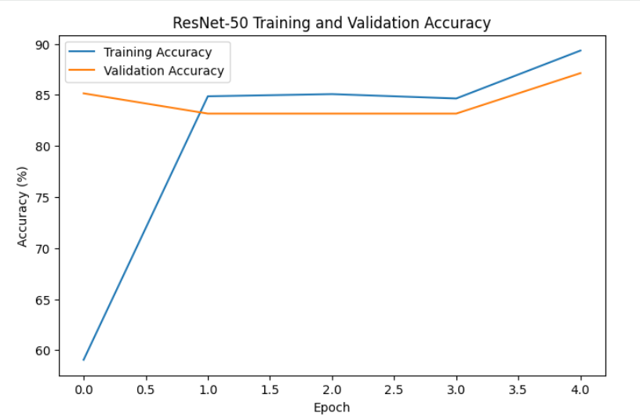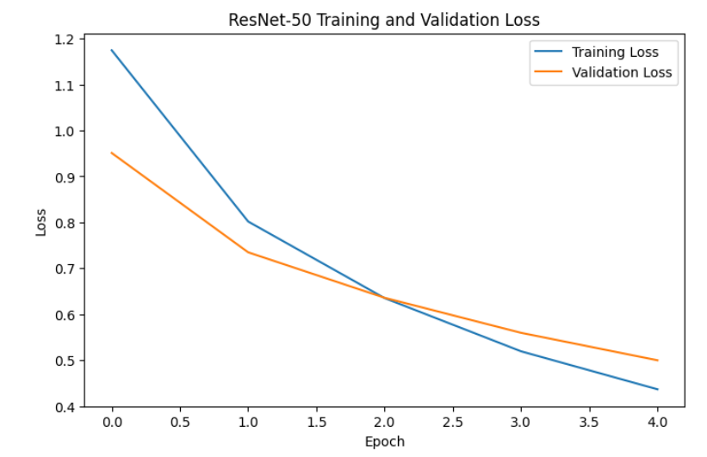

6. CNN Model Evaluation
The final evaluation was performed on 101 test images using accuracy, precision, recall, and F1-score. The final selected model achieved a test accuracy of 92.08%, weighted precision of 92.53%, weighted recall of 92.08%, and weighted F1-score of 92.24%.
Metric | Final Result
Test Accuracy | 92.08%
Weighted Precision | 92.53%
Weighted Recall | 92.08%
Weighted F1-score | 92.24%
Best Validation Accuracy | 96.04%
The class-level results showed that Red Soil achieved the strongest performance with an F1-score of 1.00. Black Soil achieved an F1-score of 0.97, Alluvial Soil achieved 0.92, and Clay Soil achieved 0.78.
Soil Class | Precision | Recall | F1-score
Alluvial soil | 0.93 | 0.90 | 0.92
Black Soil | 1.00 | 0.95 | 0.97
Clay soil | 0.74 | 0.82 | 0.78
Red soil | 1.00 | 1.00 | 1.00
The lower performance for Clay Soil indicates that this class was more difficult to distinguish from some of the other soil types.
7. Confusion Matrix and Incorrect Predictions
The confusion matrix was generated to understand the classification behaviour of the final CNN model. The model correctly classified 40 of 42 Alluvial soil images, 18 of 19 Black Soil images, 14 of 17 Clay soil images, and all 23 Red soil images.
The resulting confusion matrix was:
A total of 8 incorrect predictions were identified. The major misclassification patterns were Alluvial soil being classified as Clay soil four times, Black Soil being classified as Clay soil once, and Clay soil being classified as Alluvial soil three times.
These results indicate that the primary classification difficulty occurs between Alluvial and Clay soil. This is reasonable because soil images can contain similar visual characteristics such as texture and color.

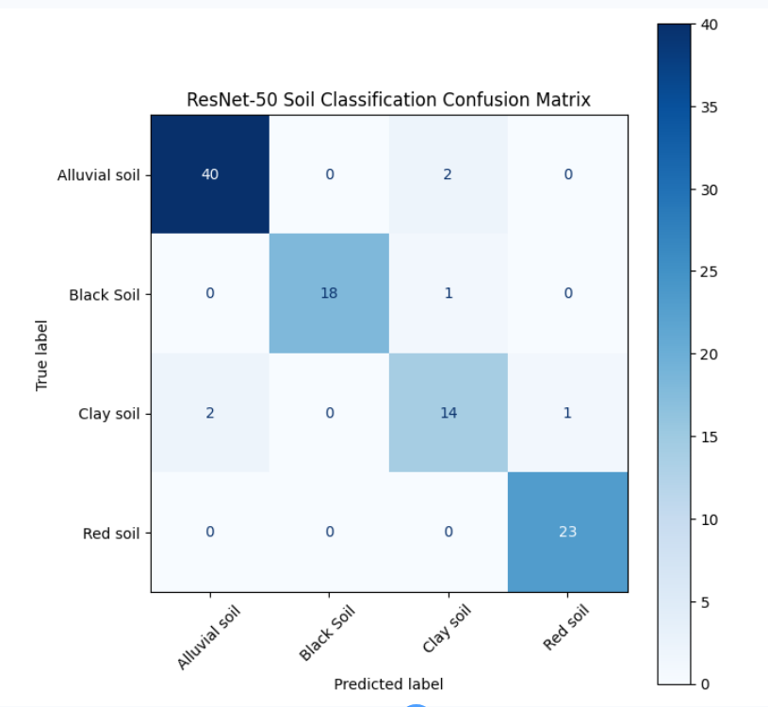

8. Individual CNN Prediction Testing
The trained CNN was also tested using representative images from all four soil classes. The model correctly classified all four selected images.
Soil Image | Predicted Class | Confidence
Alluvial_26.jpg | Alluvial soil | 99.97%
Copy of images350.jpg | Black Soil | 99.58%
Clay_13.jpg | Clay soil | 99.95%
Red_29.jpg | Red soil | 98.26%
These individual predictions demonstrate that the trained model can produce high-confidence predictions on selected test images. However, the overall test-set metrics remain the more important measure of general model performance.
9. Saving the CNN Model
The final ResNet-50 model was saved after training so that it can be reused without retraining the network. The model was saved as:
resnet50_finetuned_final.pth
The saved model includes the model state, the four soil class names, and the number of classes. The model was also backed up to Google Drive under the project's models directory. The saved model file was approximately 90 MB.
The training history was also saved separately as a JSON file to preserve the training and validation accuracy and loss information.
10. Structured Soil Data Analysis
The second part of Milestone 2 focused on structured soil information and nutrient-gap prediction. Instead of using the image data, this component uses environmental and soil-related numerical features to estimate nutrient gaps.
The nutrient gap was defined as:
Gap = Required Nutrient − Available Nutrient
This relationship was verified in the notebook, with the calculated gap matching the original gap values.
The analysis considered nutrient gaps for Nitrogen, Phosphorus, and Potassium. The dataset contained 7,744 samples and 28 candidate input features.
The features included pH and several soil, environmental, terrain, and related variables such as bio7, bio12, BulkDensity, slope, soc20, ph20, and other derived attributes.
11. Data Preparation for Structured ML
Before training the structured-data models, the available features were examined for missing values. A small number of missing values were present in features such as ecec20, hp20, xhp20, and BulkDensity.
Median imputation was applied to handle these missing values. After imputation, all 7,744 records had complete feature values.
The data was divided into training and testing sets using an 80:20 split. For the site-based evaluation, 6,195 samples were used for training and 1,549 samples were used for testing.
An important part of the experiment was the use of site-based splitting. The data contained repeated samples from the same geographical site, so splitting randomly could allow information from the same site to appear in both training and testing data. To avoid this issue, GroupShuffleSplit was used so that training and testing sites did not overlap.
The resulting split contained 655 training sites and 164 testing sites, with zero shared sites.
12. XGBoost for Nutrient-Gap Prediction
XGBoost, or Extreme Gradient Boosting, is a tree-based ensemble learning algorithm that builds multiple decision trees sequentially. Each new tree attempts to improve the errors made by the previous trees. XGBoost is suitable for structured numerical data because it can model nonlinear relationships between input variables and target values.
In this project, XGBoost regression models were developed separately for Nitrogen, Phosphorus, and Potassium gaps.
The initial configuration used 300 estimators, a maximum tree depth of 6, a learning rate of 0.05, subsampling of 0.8, and column sampling of 0.8.
13. Nitrogen Gap Model
The Nitrogen gap dataset contained 7,744 samples with 28 input features. The XGBoost model was evaluated using Mean Absolute Error (MAE), Root Mean Squared Error (RMSE), and R².
The site-based Nitrogen model achieved an MAE of 942.57, an RMSE of 1315.36, and an R² value of 0.4323.
The results indicate that the model was able to capture a meaningful portion of the variation in Nitrogen gap values, although there is still considerable prediction error.
The most important features in the site-based model included ph20, pH, mb2, mdem, and soc20.
14. Phosphorus Gap Model
The Phosphorus gap dataset also contained 7,744 samples and 28 features. The site-based XGBoost model produced an MAE of 43.89, an RMSE of 99.75, and an R² value of 0.0705.
The relatively low R² indicates that predicting the continuous Phosphorus gap was considerably more difficult than predicting the Nitrogen and Potassium gaps using the selected features.
The model's most important features included ph20, slope, hp20, bio15, and ecec20.
For practical interpretation, the continuous Phosphorus prediction was also converted into a binary status based on whether the predicted gap was greater than zero.
15. Potassium Gap Model
The initial site-based Potassium XGBoost model achieved an MAE of 323.09, an RMSE of 465.43, and an R² of 0.5023.
Hyperparameter tuning was performed by comparing several XGBoost configurations. Four configurations were tested by changing tree depth, number of estimators, and learning rate.
Configuration | MAE | RMSE | R²
Baseline | 323.09 | 465.43 | 0.5023
Shallow | 325.41 | 464.38 | 0.5046
Deeper | 327.35 | 471.41 | 0.4895
Lower Learning Rate | 321.61 | 466.30 | 0.5005
Based on the notebook's selection criterion of highest R², the Shallow configuration was selected. The final tuned Potassium model used 300 estimators, maximum depth 4, learning rate 0.05, subsample 0.8, and column sampling 0.8.
The selected model achieved an R² of 0.5046.

16. Overall Structured Model Results
The main results from the three nutrient-gap models are summarized below.
Nutrient | MAE | RMSE | R²
Nitrogen | 942.57 | 1315.36 | 0.4323
Phosphorus | 43.89 | 99.75 | 0.0705
Potassium | 325.41 | 464.38 | 0.5046
The results show that the Potassium model produced the highest R² among the three nutrient-gap models, while the Phosphorus model had the lowest R². Therefore, the structured-data component is useful for estimating nutrient gaps, but its predictive strength varies considerably by nutrient.

17. Nutrient Gap Classification
The continuous nutrient-gap predictions were converted into nutrient status categories. A positive predicted gap was treated as a Positive Gap, while a value less than or equal to zero was treated as No Positive Gap.
Across the 1,549 test samples, the models predicted positive Nitrogen gaps for 0 samples and positive Potassium gaps for 0 samples. For Phosphorus, 903 samples were predicted to have a positive gap, representing 58.30% of the test set.
For comparison, the actual data contained 1,230 positive Phosphorus gaps, representing 79.41% of the test set.
The binary Phosphorus-gap classification achieved an accuracy of 69.85%, with a weighted precision of 81.19%, weighted recall of 69.85%, and weighted F1-score of 72.65%.
The confusion matrix was:
Predicted
No Gap Gap

Actual No Gap 249 70
Actual Gap 397 833
This shows that the model correctly identified 833 of the 1,230 actual positive-gap cases, while 397 positive-gap cases were classified as having no positive gap.

18. Explainable AI
Explainable Artificial Intelligence was incorporated to make the model predictions easier to understand. Two techniques were used in the project: Grad-CAM for the CNN image model and SHAP for the structured-data model.
Explainability is important because an AI system used for agricultural decision-making should provide more than just a prediction. Understanding what the model is focusing on can help identify whether it is using meaningful soil characteristics or irrelevant patterns.

19. Grad-CAM for Soil Images
Grad-CAM, or Gradient-weighted Class Activation Mapping, was applied to the ResNet-50 model. Grad-CAM produces a heatmap showing the regions of an input image that contributed most strongly to a particular prediction.
For the ResNet-50 model, the final convolutional block, specifically layer4[-1], was selected as the target layer for generating the activation map.
A correctly classified Alluvial soil image was used first to verify the Grad-CAM implementation. The prediction was Alluvial soil, matching the actual class.
The generated Grad-CAM values had a minimum of 0, a maximum of approximately 1.0, and a mean activation of approximately 0.2572.
Grad-CAM was also generated for one of the incorrectly classified images. This allows the model's attention to be examined when it makes a classification error and provides insight into why visually similar soil categories may be confused.
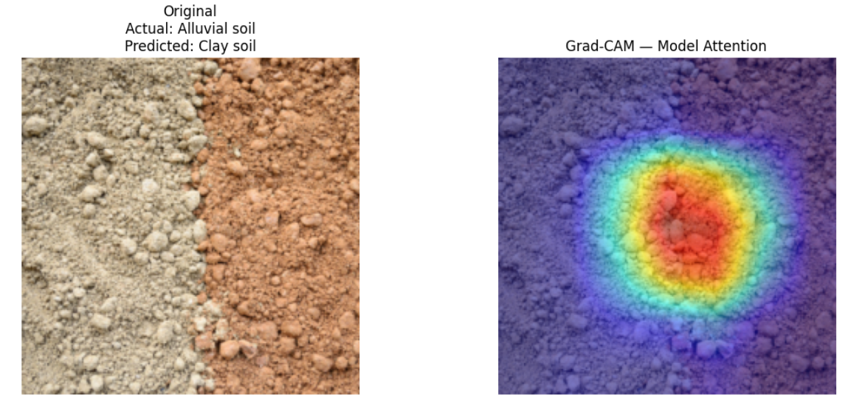

20. SHAP Analysis
SHAP, or SHapley Additive exPlanations, was used to understand the contribution of structured features to the model prediction. SHAP assigns an importance value to each feature based on its contribution to the prediction.
In this project, SHAP was applied to the Potassium-gap XGBoost model. SHAP values were calculated for all 1,549 test samples across the 28 input features.
The most influential features according to mean absolute SHAP importance were:
Feature | Mean Absolute SHAP
pH | 219.59
bio7 | 185.89
bio12 | 66.40
mb2 | 48.67
lstd | 36.05
The results indicate that pH had the largest average contribution to the Potassium-gap model predictions, followed by bio7 and bio12.
The SHAP analysis provides an interpretable view of which environmental and soil-related features are influencing the model rather than treating the XGBoost model as a complete black box.
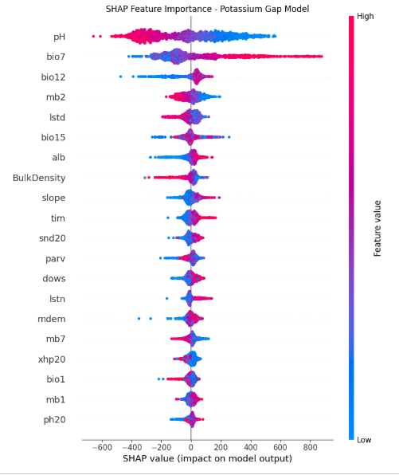
21. Hybrid Soil Analysis
The final stage of Milestone 2 combines the CNN soil classification output with the structured nutrient-gap predictions.
The hybrid system first uses the ResNet-50 model to identify the soil type and calculate the CNN confidence. The structured soil features are then passed to the Nitrogen, Phosphorus, and Potassium gap models. The resulting nutrient gaps are converted into nutrient-status labels.
The system then calculates a soil-health score based on the number of nutrients with a positive gap. Each nutrient contributes equally to the score.
The scoring method used in the implementation is:
Soil Health Score = ((Total Nutrients − Positive Gaps) / Total Nutrients) × 100
The resulting categories are defined as Good for scores of 80 or above, Moderate for scores between 60 and 79.99, and Needs Improvement for scores below 60.

22. Hybrid Assessment Results
Four representative soil images were tested together with structured soil samples. The CNN correctly identified all four soil classes with high confidence.
Soil Type | CNN Confidence | N Status | P Status | K Status | Health Score
Alluvial soil | 99.97% | No Positive Gap | Positive Gap | No Positive Gap | 66.67
Black Soil | 99.58% | No Positive Gap | No Positive Gap | No Positive Gap | 100.00
Clay soil | 99.95% | No Positive Gap | No Positive Gap | No Positive Gap | 100.00
Red soil | 98.26% | No Positive Gap | No Positive Gap | No Positive Gap | 100.00
The first hybrid assessment, using the Alluvial soil sample, produced a CNN confidence of 95.51%. The predicted Nitrogen gap was −3576.23, the Phosphorus gap was 6.37, and the Potassium gap was −459.43. Since only Phosphorus had a positive gap, the resulting soil-health score was 66.67/100, categorized as Moderate.
After the tuned Potassium model was integrated, the Alluvial sample's Potassium prediction changed to approximately −399.87, while its overall health score remained 66.67 because the nutrient status remained unchanged.

23. Model and Result Storage
The trained models and generated outputs were saved so that the work can be reused in later stages without repeating the complete training process.
The ResNet-50 model was stored in the project's Google Drive models directory. The nutrient-gap XGBoost models were stored under the soil_gap_models directory, together with the feature lists, imputer, and NPK assessment results.
The final hybrid assessment was also exported as a CSV file containing four test assessments and eleven output columns.
The main saved artifacts include the trained ResNet-50 model, Nitrogen-gap XGBoost model, Phosphorus-gap XGBoost model, tuned Potassium-gap XGBoost model, feature definitions, preprocessing imputer, training history, and hybrid assessment results.
Deliverable | Status
CNN soil classification model | Completed
ResNet-50 fine-tuning | Completed
CNN evaluation | Completed
Confusion matrix | Completed
Incorrect prediction analysis | Completed
Grad-CAM | Completed
NPK gap models | Completed
XGBoost tuning | Completed
SHAP analysis | Completed
Hybrid soil assessment | Completed
Trained model backup | Completed

24. Milestone 2 Deliverables
The main deliverables produced during Milestone 2 are summarized below.

25. Challenges and Observations
The CNN results show that soil classification is generally effective, but visually similar soil types remain challenging. The main confusion occurred between Alluvial and Clay soil. This suggests that additional image diversity and more representative training samples could improve classification performance.
The structured-data results also showed that nutrient prediction performance differs significantly between nutrients. Potassium achieved the highest R² value of 0.5046 after tuning, while Phosphorus achieved only 0.0705. This indicates that the currently available features explain some nutrients better than others.
Another important observation is that the nutrient-gap models use a combination of soil and environmental features rather than only the three NPK measurements. Features such as pH, bio7, bio12, and other environmental variables played an important role in the predictions.
The use of site-based splitting also provides a more realistic evaluation because samples from the same site were prevented from appearing in both training and testing sets.

26. Overall Milestone 2 Outcome
Milestone 2 successfully developed the major AI/ML components of the soil analytics system. The ResNet-50 transfer-learning model was trained and fine-tuned for four-class soil image classification. The final model achieved 92.08% test accuracy, with weighted precision of 92.53%, recall of 92.08%, and F1-score of 92.24%.
For structured soil analysis, separate XGBoost regression models were developed for Nitrogen, Phosphorus, and Potassium nutrient gaps. The best Potassium model achieved an R² of 0.5046 after hyperparameter tuning, while the Nitrogen and Phosphorus models achieved R² values of 0.4323 and 0.0705 respectively.
Grad-CAM was successfully implemented to visualize important image regions used by the CNN. SHAP was applied to the Potassium-gap model and identified pH as the most influential feature based on mean absolute SHAP importance.
Finally, the CNN predictions and nutrient-gap predictions were combined into a hybrid soil-assessment workflow. The system produced soil-type predictions, nutrient-gap statuses, confidence values, and an overall soil-health score.

27. Conclusion
Milestone 2 established the core AI/ML engine of the proposed soil analytics system. Transfer learning with ResNet-50 provided an effective approach for identifying soil types from images, while XGBoost regression was used to estimate nutrient gaps from structured soil and environmental features.
The evaluation results demonstrate that the image-classification component can distinguish the four selected soil classes with good overall performance. The structured-data experiments also demonstrated that machine learning can estimate nutrient gaps, although the prediction quality varies between nutrients.
The integration of Grad-CAM and SHAP improves the interpretability of the system by showing the image regions and structured features that influence model predictions. The hybrid assessment further demonstrates how image classification and structured soil analysis can work together to produce a more comprehensive soil-health assessment.
The completed models, evaluation results, explainability outputs, and hybrid assessment provide the AI/ML foundation required for the next stage of the project, where the soil analysis engine can be further integrated with crop recommendation and the final application workflow.

